Privacy Notice 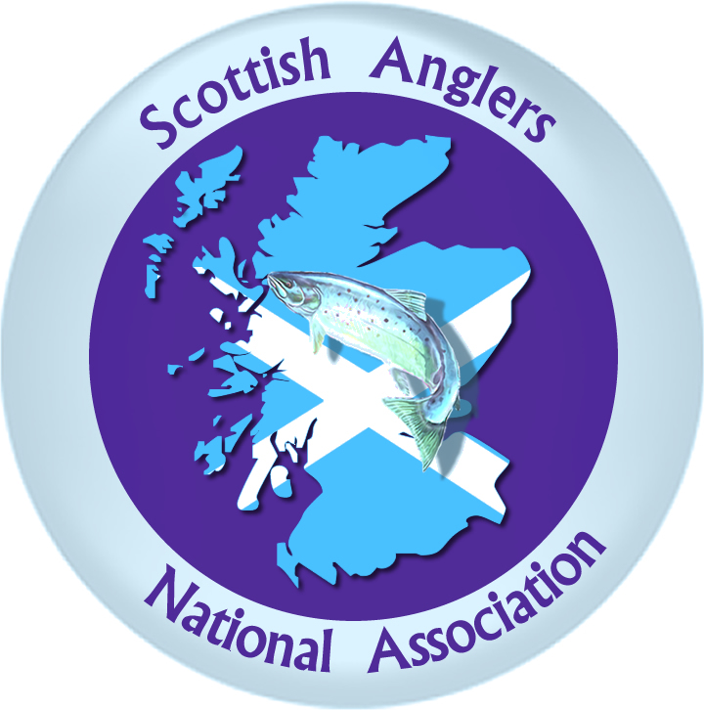

Angling Scotland Ltd and The Scottish Anglers National Association Ltd (SANA). will be a “controllers” of the personal information that you provide to us by post, email or phone or on our online membership system (known as Azolve), unless otherwise stated.
When you register as a member of SANA or renew your membership (including if you are registering or renewing on behalf of a child under the age of 16), we will ask you for the following personal information:
- contact details – name, address, email address (for children under 16 this is the email address of the parent), and date of birth for youths under 18
- membership criteria/category – Club, Individual, Professional, Associate or Youth
- We will ask clubs for the contact details of any Child Protection Officer where applicable
- Clubs will also be asked for the total the number of members against the following categories – Male, Female, Youths, Disabled person and those of ethnic origin. These categories are required for reporting purposes to Sportscotland.
- equality information – e.g. disability (Where the SDFFA require disability information this is used to ascertain membership elegibility only and is then destroyed)

Why we need your personal information – contractual purposes
We need to collect our members’ personal information so that we can manage their membership. We will use our members’ personal information to:
- provide you with core member services, including, insurance, licensing and PVG checks;
- set up your online membership account and administer your account online
- send you membership communications by post, email or SMS in relation to essential membership services, including but not limited to, membership renewals and information on membership benefits
If you do not provide us with all of the personal information that we need to collect then this may affect our ability to offer the above membership services and benefits.
Why we need your personal information – legitimate purposes
We also process our members’ personal information in pursuit of our legitimate interests to:
- promote and encourage participation in angling by sending members’ communications and booking information for upcoming competitions and events. Our competitions and events may be filmed for live streaming purposes and your personal information may also be used in images captured from our competitions and events, which we use for promotional, education and development purposes
- provide competition in angling by accepting and managing entries for our competitions and checking your personal information to ensure you are entered into the correct category
- monitor and develop participation in angling by monitoring members’ engagement and participation through attendance and inviting our members to participate in surveys for researching and development purposes
- develop and maintain our members’ qualifications, including sending email communications to members to inform you of upcoming courses, renewal requirements and verify that you have completed any mandatory training and PVG / child protection requirements
- respond to and communicate with members regarding your questions, comments, support needs or complaints, concerns or allegations in relation to aquatic sports. We will use your personal information to investigate your complaint, to suspend membership and take disciplinary action where appropriate
Where we process your personal information in pursuit of our legitimate interests, you have the right to object to us using your personal information for the above purposes. If you wish to object to any of the above processing, please contact us at admin@SANA.org.uk. If we agree and comply with your objection, this may affect our ability to undertake the tasks above for the benefit of you as a member.

Why we need your personal information – legal obligations
We are under a legal obligation to process certain personal information relating to our members for the purposes of complying with our obligations under:
- the Companies Act 2006 to maintain a register of our members, which includes our members’ name, address, the date they were admitted to membership and the date on which they ceased to be our member, and hold general meetings, including issuing notices and voting arrangements
- our sportscotland regulatory requirements to report on the size, achievements and profile of our members
- the Equality Act 2010, which requires us to process personal information to make reasonable adjustments where necessary
Why we need your personal information – equality monitoring requirements
We are required to use our members’ personal information relating to your disability (if any), or (ethnic group, religious belief, gender identity and sexual orientation where collected) for equality monitoring purposes as required by sportscotland.
We will process such personal information through aggregated and anonymised reports to identify and keep under review the existence or absence of equality of opportunity or treatment between groups of people within the same categories to promote or maintain equality within our sport.
Other uses of your personal information
We may ask you if we can process your personal information for additional purposes. Where we do so, we will provide you with an additional privacy notice with information on how we will use your information for these additional purposes.
We may be asked by our member clubs to collect and store personal information about their individual members. Where we do this, the clubs have a responsibility as “controllers” to provide their members with privacy notices and we will not use such personal information for any other purpose.
Who we share your personal information with
If your personal information is included in any images or videos taken by us at our competitions and events, we may share this with members of the Scottish media, sponsors, sportscotland and Sports Partners for promotional and/or journalistic purposes. We will also make use of our websites and Social media pages.
For active competitive members, your basic personal information (name, gender, year of birth if over 16 and passport details as well as photographs to FIPS Mouche for competition registration purposes.
We may be required to share personal information with statutory or regulatory authorities and organisations to comply with statutory obligations. Such organisations include the Health & Safety Executive, Disclosure Scotland, and Police Scotland for the purposes of safeguarding children.
We may also share personal information with our professional and legal advisors for the purposes of taking advice.
In the event that we do share personal information with external third parties, we will only share such personal information as is strictly required for the specific purposes and take reasonable steps to ensure that recipients shall only process the disclosed personal information in accordance with those purposes.
SANA Ltd along with Angling Scotland Ltd us Azolve (Go Membership) to administer our membership database, as part of which Azolve contracts third party payment providers to process your payments of our behalf. Azolve and its payment providers process our members’ personal information on our behalf as “processors” and are subject to written contractual conditions to only process that personal information under our instructions and protect it.
The individual governing bodies also may use internal membership databases and paper membership forms
SANA will use voice recording at some meetings. This is purely for the purpose of accurate minute production and the recordings are deleted and cannot be used for future reference.
How we protect your personal information
Your personal information is stored on our electronic filing system, on paper records and software programmes. We use Google Drive Stream as part of our backup strategy and they uphold the EU Privacy Shield to certify their data security. Mailchimp may distribute some of our email communications. Their servers are based in the US and they uphold the EU Privacy Shield to certify their data security
How long we keep your personal information
We will only keep your personal information for as long as necessary to provide you with membership services. Unless you ask us not to, we will review and possibly delete your personal information where you have not renewed your membership with us for four years.
We will keep certain personal information of members for longer in order to confirm your identity, when you were a member of Scottish Anglers National Association Ltd and for how long. We need to do this to comply with the Companies Act 2006, which requires us to keep a register of members or in the event of a claim against Scottish Anglers National Association Ltd.
Your rights
You can exercise any of the following rights by writing to us at admin@sana.org.uk
Your rights in relation to your personal information are:
- you have a right to request access to the personal information that we hold about you by making a “subject access request”
- if you believe that any of your personal information is inaccurate or incomplete, you have a right to request that we correct or complete your personal information
- you have a right to request that we restrict the processing of your personal information for specific purposes
- if you wish us to delete your personal information, you may request that we do so
Any requests received by SANA Ltd will be considered under applicable data protection legislation. If you remain dissatisfied, you have a right to raise a complaint with the Information Commissioner’s Office at www.ico.org.uk

